If you have connected to my pages/website/etc., I say Hello on this 364th day of the 2024 year. It has been an interesting and difficult year, but one thing great that has happened I would like to tell you about and offer to you because Day 1 of the new year is about to start. As you probably figure I usually read through the Bible each year. Yes, it takes perseverance, but this year I discovered a most relaxing and interesting new way to accomplish this and even got Kathy doing this Bible reading together with me and that’s a treasure to me! Let me tell you how this has worked so well and easily.

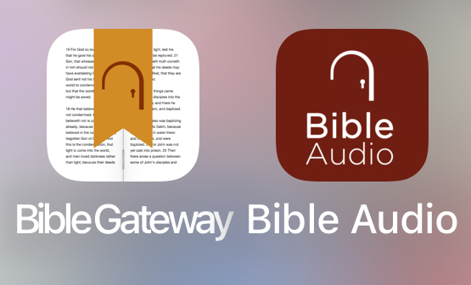
First, truth be told it was by accident as I heard about this method as I heard about it during an interview playing in the background as I worked in my computer. Then I looked into it and tried it. It offers a choice of scriptural front to back or by Chronological order which I try to do every other year. I chose Chronological order this year. You then have the choice of the Bible Translation and the person you like to listen to read it as you follow word by word. I’ve always read by myself but found this method of listening and following along as he read refreshing and enjoyable. At first, I chose different Bible Translations almost daily as I enjoy the difference in wording. However, as Kathy joined me daily we went with the NIV or New Internation Version since Kathy enjoys that one best.

This first part daily comes by downloading a free App called “Bible Audio” which is part of Bible Gateway. The app looks like the red version called Bible Audio.

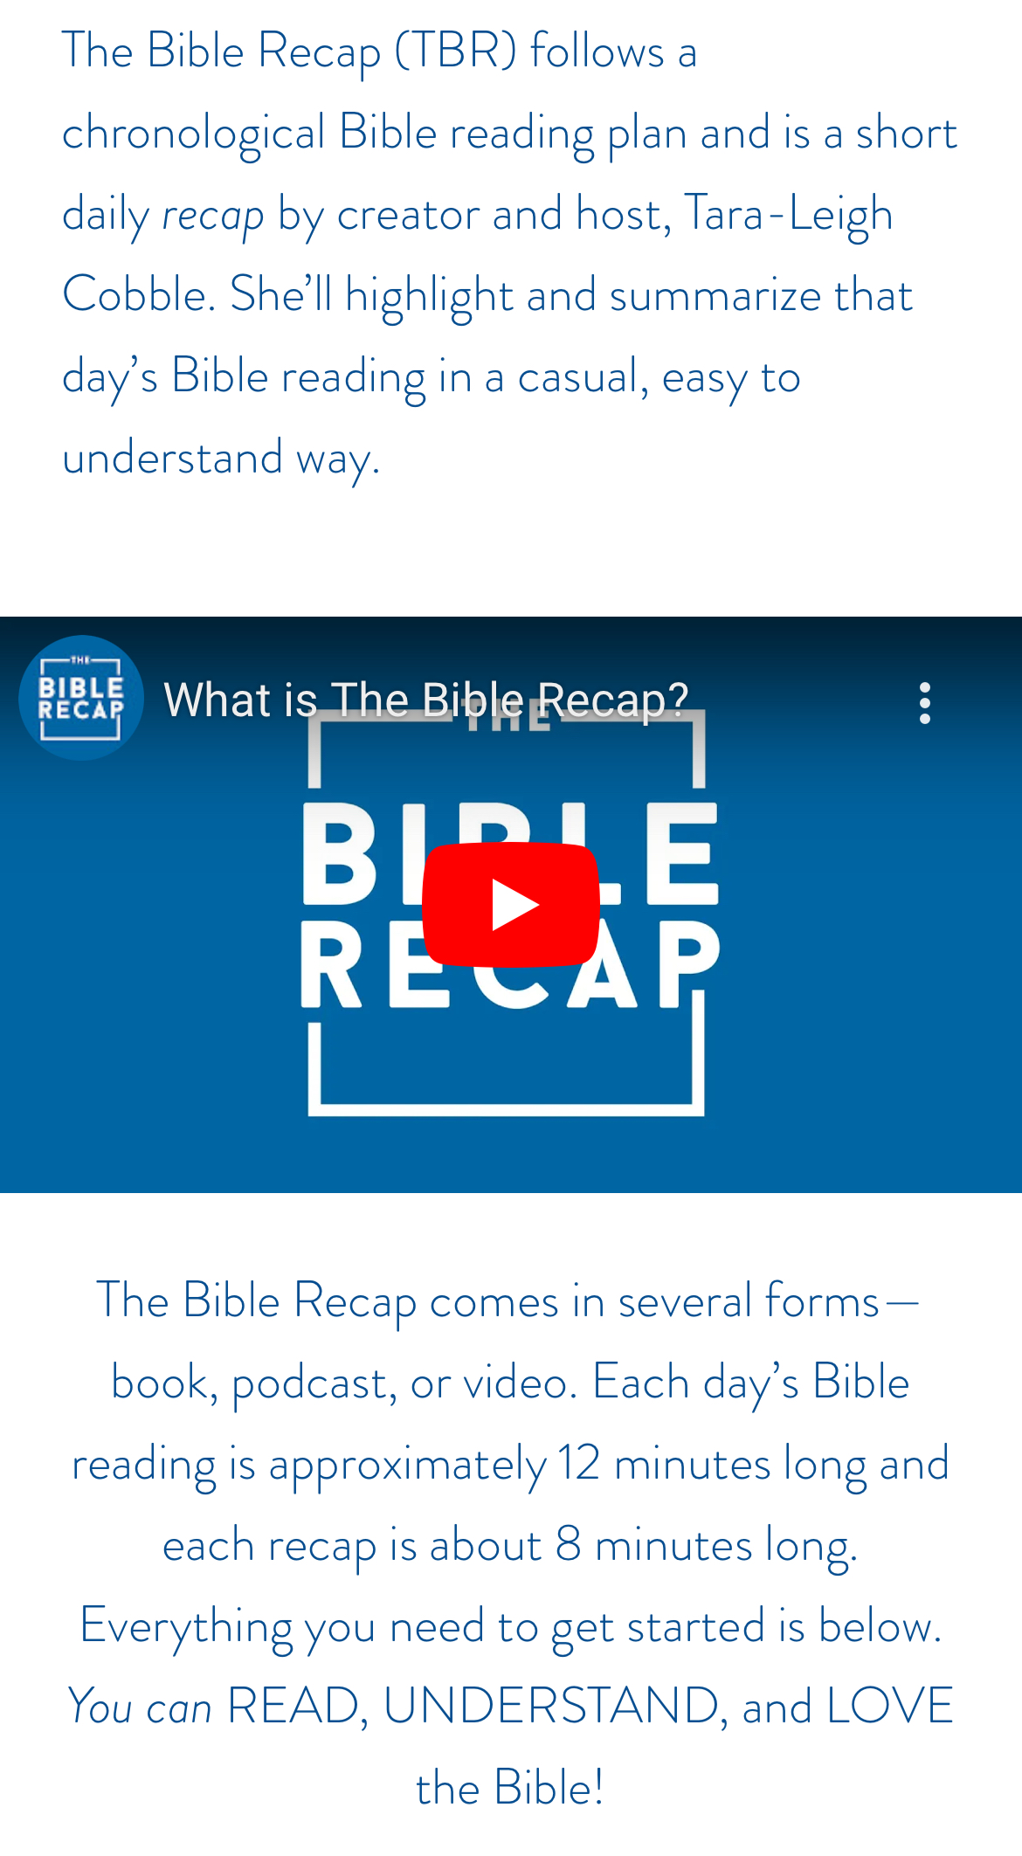
Then, what I call “Part 2” and the really interesting part of this read/watch/ and listen daily Bible study time which all together has never gone past 20 minutes is done by Tara-Leigh Cobble and it is called “The Bible Recap.”

She does an excellent and interesting job of sumerizing the Bible chapters that you just read along with. She keeps it short and will likely fill you in on what was going on at the time during what you just read if you are unfamiliar to that piece of Bible History. And, she does Revelation well and conservatively also. I hope that you take a few days to try these Bible treasures out and enjoy it like we do.

Here is what the App looks like and hopefully you can read just a bit of what she does in the podcast each day. This along with listening / reading along has never got past 20 minutes all together and that’s relaxing and not a time crusher. I usually go to the Bible Recap on YouTube on my TV, but its available on my cell phone and almost anywhere, so this whole thing is so simple each day.

I hope that time with the Bible becomes a joy and treasure daily. And you can start anytime, not just January first.

Blessings to you, from Kathy and me throughout the New Year 2025 Bob & Kathy

